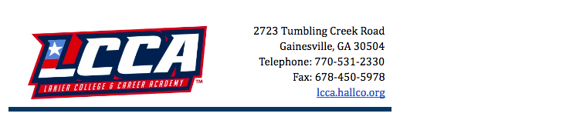
Important
Upcoming Dates

SkillsUSA Month
All September

Labor Day – No School
September 2nd

Resume Bus
September 12th

Community Job Fair
September 24th 2-6pm
Gainesville Civic Center

HS Work At Home Day
September 25th
Details to be announced

LCCA Leadership Retreat
September 27th-29th

LCCA Car Show
October 12th

Bus Driver Appreciation Day
October 21st

September 2019

Message from the Principal

Dear LCCA families,
It is hard to believe September is already here! We have had a great start to the school year and we are finally settling into our routine.
We appreciate your support as we make this journey in our quest to help all of our students become JOB READY!
Please do not hesitate to contact us if you should need assistance. Our staff will be happy to help!
Sincerely,
Mr. Jeff Jenkins
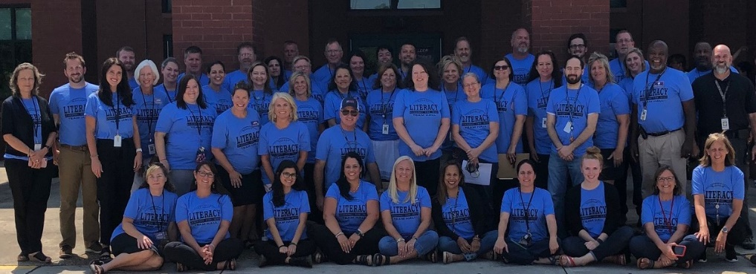
LCCA Faculty and Staff on First Day of 2019-2020 School Year

#WBLWORKS
The Work-Based Learning program at LCCA has much to celebrate! The following students have been placed by local business partners: Shi Williams-Pilgrims Pride; Luke Nave–Boys & Girls Club; Wyatt Wallace–Kubota Manufacturing. Currently, we have 31 students in the WBL program & have several lined up for interviews this week.
Be sure to follow us on Twitter @lcca_work for events, opportunities and updates!

Hospitality and Culinary Arts
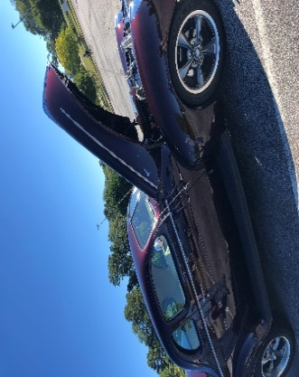
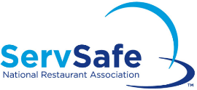
Students have been working to earn the following certificates: OSHA for safety in restaurants and ServSafe for sanitation. Both certificates are recognized throughout the industry. LCCA students are JOB READY and more marketable with these certifications.
LCCA's own Nurse Allison's husband is a restoration expert. This is one of his restored vintage cars!

9th Annual LCCA Car Show
The HVAC & Construction programs will be hosting their annual fundraiser on October 12th. Prizes and recognition of Best of Show, Decade, Principal's Choice, and People’s Choice just to name a few will be awarded. If you know someone with a vintage car, please encourage them to support LCCA! All are welcome to join us for food, fellowship, and awesome cars!

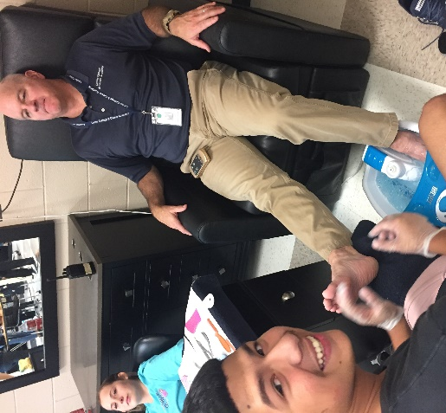
Cosmetology
COUNSELOR’S CORNER

Hello LCCA family! My name is Laren Chandler; I am the counselor for all students here at LCCA. I work with your students across many areas, including academic scheduling, graduation planning, individual counseling, group counseling, and mental health promotion. I hope that you will encourage your students to seek counseling help if/when needed. If you would like to make an appointment for yourself or your student, please visit: bit.ly/LCCAcounselor. Thank you!
Cosmetology students have been brushing up on their practical skills to get ready for clients on Fridays. Advanced students have been peer teaching manicures and pedicures to Intro students.
Reflections Salon and Spa will be open on Friday, September 13th. Call to book your appointment 770-531-2330 ext. 400.
Mr. Jenkins supporting our Cosmetology program by receiving a pedicure from Brian Gomez.

New Beginnings
Hello, my name is Holly Klippel, and I am the School Social Worker for Lanier College and Career Academy. We hope that you and your students are off to a great school year! Transitioning from summer back into an organized and structured school schedule can often be stressful and challenging for some students. To help alleviate some of this stress it is beneficial for students to plan ahead, map out a schedule that works for them, and set some goals. You can help make this year a successful one by helping your student to manage their time, make attendance a priority, communicate any needs as they arise, and remain engaged with school. Aside from monitoring attendance, school social workers also work to support students within the classroom and link families to any community resources outside the classroom. These resources can include anything from basic needs to mental health counseling to childcare. For a list of these resources please visit our school site and click on “parent toolbox” where you will find a community resource guide. Please feel free to reach out if there is anything we can do to help ensure your child’s success!

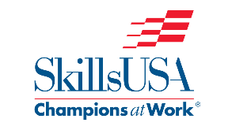
SkillsUSA
SkillsUSA is a partnership of students, teachers, and industry working together to ensure America has a skilled workforce. SkillsUSA helps each student excel. It is a chance for our students to show off their skills and talents. The club is open to any student enrolled in a career tech class.
LCCA Leadership Retreat at the FFA Camp in Covington is on September 27th-29th.
Region Competition is January 23rd, 2020. If you are interested in signing up for SkillsUSA, (CTAE and Academic) students see Ms. Laster for more information.
Student Council
Student Council is a wonderful opportunity for students to get involved, grow their leadership skills, and support their community. If your child is interested, please encourage him or her to see Mrs. Eberhardt or Mrs. Rudeseal for details.
Job Fair
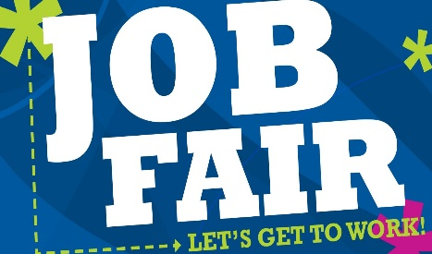
Express Employment Professionals is hosting a job fair at the Gainesville Civic Center on Tuesday, September 24th from 2:00-6:00pm. Employers will be ready for face-to-face interviews. 60+ employers will be present with hiring managers on site. Contact Amanda Lewis for more details at 770-532-6206 or alewis@ghcc.com.

